PERU

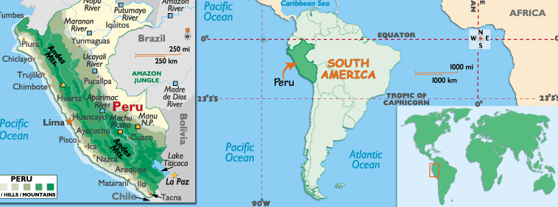

VISA The visa is to be obtained prior to arrival in the country
HOW TO GET THERE:
CURRENCY:
-The currency of Peru is the Nuevo Sol.
US $1 = 3.3 nuevo soles.
-Coins are available in 5, 2 and 1 sol, and in 50, 20, 10, 5 and 1 cent. 5 and 1 cent coins are not normally accepted outside of big supermarkets or banks, so avoid them.
- Notes are available at 10, 20, 50, 100 and 200 soles denominations; 200 soles notes are uncommon and will not be accepted in the same places that will not accept a 100 USD note or a 50 pound note.
- Counterfeiting is common: take time to get familiar with the money and do not hesitate to reject any note or coin (especially the 5 sol coins) that look suspicious.
- If you are stuck with a counterfeit coin or note, if you try to use it at big stores they may want to confiscate it.
- Don't accept damaged bills, since you will have to take them to a bank in order to change them into new ones before you can spend them. Be especially careful when exchanging money at the border (notably the one with Ecuador).
- Traveler’s checks or credit cards are usual. Although cash has a ca. 2% better change rate, you are strongly advised not to carry large amounts of cash on your journey.
-The Banco de Credito (BCP) gives good rates on traveler checks. Rates in change offices are often somewhat worse. It's always worth comparing them before changing your money. When changing your money in change offices, control their calculations.
-Even in the bank, check your bills for authenticity.
-ATMs are available in big cities, upmarket hotels and tourist areas. With a Cirrus or Maestro sign on it, you can withdraw cash easily. The exchange rate is the same as credit cards but fees are much lower.
-In smaller towns, it can happen that there are nobody who will accept your credit card or traveler checks. For this case, you should have taken care that you have enough cash with you. Nice new Dollar bills (not too high,10 or 20 US$ bills are fine) can help, too, since they are easier to change than travelers checks. In Peru, it not as common for US$ to be accepted in transactions as in other countries. Often in small towns, local shops will change money for you. If so, it will be clearly marked. Take only US$ bills in good condition since bills slightly torn or even old-looking will not be accepted

TRAVELLING BETWEEN CITIES:
There are flights between Lima (LIM) and Cuzco(CUZ) every half an hr. The flying time is 1hr.
The airlines that operate between Lima and Cuzco are Lan Peru (LP) and Taca International (TA)

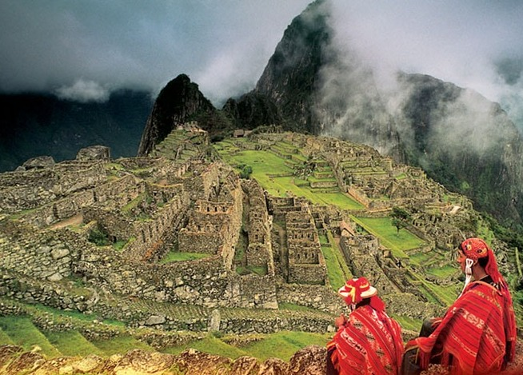

GETTING AROUND:
-Inside the cities, there is usually no problem getting around on taxis.
-Taxis cost between 7 and 8 soles (US$ 2.00 - 2.40) in Lima, normally less in other cities.
-Taxis are divided between "formal" taxis, painted and marked as such, and informal ones, that are just cars with a windshield sticker that says "Taxi".
-Apart from the more upscale radio taxi (also the more expensive ones), the fare is not fixed or metered, but it is negotiated with the driver before getting into the vehicle.
- Ask at your hotel about the rate you may expect to pay to ride to a specific location to have a point of reference. There is no tipping at taxis.
Hence it is advisable to use only taxi companies requested by phone or authorized by city halls, which are yellow colored and show their license plate number on both sides of the vehicle.
(http://wikitravel.org/en/Peru#)

COUNTRY DIALING CODE:
+51

TIME DIFFERENCE:
10.5 hrs behind India.

DUTY FREE:
Travelers to Peru over 15 years do not have to pay duty on 400 cigarettes or 50 cigars; 2kg of food maximum; 3 bottles of alcoholic beverages not exceeding 2.5 litres; and gifts to the value of US$300. Items such as sausages, salami, ham and cheese may only be brought in if accompanied by an original sanitary certificate. The import of ham from Italy and Portugal is prohibited. The export of cultural or artistic items from the country is not permitted.

LANGUAGE:
Spanish and Quechua are the official languages, but many other dialects are spoken. English is spoken only in major tourist centres and hotels.

MUST CARRY:
Sun block and hat, sunglasses are necessary, carry plenty of water.

TAXES:
All sales in Peru are levied with 19% IGV.

ELECTRICITY:
The whole electric system of Peru is of 220 volts and 60 cycles.
Some hotels of 5 and 4 stars have additionally electric systems of 110 volts.

TIPS:
For good service a tips of 10% is considered polite.

CITIES:

LIMA- the City of Kings
Positioned halfway down the dry and dusty desert coastline of Peru, the city of Lima is hemmed in by the Pacific Ocean on the one side and the foothills of the Andes mountain range on the other
Jorge Chávez International Airport (LIM)Location: The airport is situated 10 miles (16km) north west of Lima. Transfer to the city: Taxis can be found outside the international flights terminal. Buses and minibuses also service the city centre, but their stops are outside the airport gates on Avenida Faucett. They travel to the city, stopping along the main avenues. Car rental: Car rental companies include Hertz, Budget and National. Facilities: Facilities at the airport include banks, bureaux de change, ATMs, a post office, public telephones, a couple of restaurants, shops, left luggage and a tourist information desk. There are disabled facilities; those with special needs should contact their airline in advance. Parking: Departure tax: US$30.25 or the equivalent in soles (international). Website:www.lap.com.pe
Climate
Lima is warm and sticky across the seasons, with very little rainfall. January through March brings warm, humid days with temperatures of about 26°C (79°F), and nightly lows, which hover around a pleasant 20°C (68°F). The afternoon humidity relaxes a little during March and April, and the sun washes over the countryside. Between April and December, however, garúa (coastal fog) shrouds the sun.
http://www.wordtravels.com/Cities/Peru/Lima/Attractions

MUST SEES:

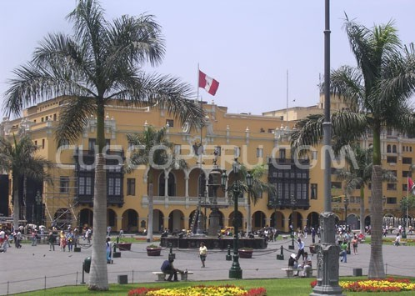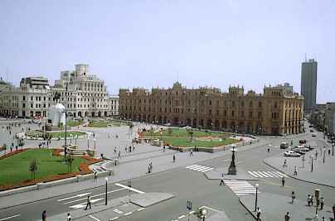

Plaza de Armas, Central Lima
This is the spot where Francisco Pizarro founded the city in 1535. The north side is dominated by the Government Palace (rebuilt in 1937), home of Peru's president. You can watch the changing of the guard here at 11:45 each morning.
On the east side of the Plaza, you will find the Cathedral. Unfortunately, it was reduced to rubble in 1746 by an earthquake and was subsequently rebuilt and completed by 1755. The supposed remains of Francisco Pizarro lie in a small chapel, the first on the right of the entrance, in a glass coffin.
Open Tues-Sun 10:00 - 18:00
Entrance fee of US$2 includes entrance to the Religious Art Museum inside.

Plaza Mayor and Plaza San Martin
A long pedestrian street crowded with shoppers, vendors, and sightseers connects Lima's two main plazas to each other. The heart of the old town is centred on the striking Plaza Mayor, or Plaza de Armas, gracefully colonial with its bronze fountain and old street lamps. It was once the central marketplace, where bullfights were held during Spanish rule. Surrounding the square are several notable buildings, including the grand Spanish Baroque Cathedral, occupying the site of an ancient Inca temple and housing the Museum of Religious Art and Treasures; the impressive Government Palace where the changing of the guard takes place; the Town Hall; and the Archbishop’s Palace sporting a beautiful wooden balcony. The Plaza San Martin is an impressive square with a hive of activity surrounding its central fountains; a busy area of shoe-shiners, soapbox speakers, street artists and the site for political rallies and rioting workers.

The Cathedral
The Cathedral, which has become one of the main symbols of the city, started construction the same year the city was founded; 1535. Since then there have been numerous remodilations. The Basilica Cathedral of Lima displays a form architecture that makes it unique in all of South America, of the style of the viceroyal time. The benches of the cathedral are of the finest quality as well are the of the benches of their Choir. The Greater Altar is covered with gold bread and has images of the viceroyal time. Within the Cathedral, are the ashes of the founder of the City of the Kings, today City of Lima, Francisco Pizarro

Church of SanFrancisco:
The most spectacular of Lima's colonial churches, San Francisco is a striking white and yellow building with twin towers and a stone façade. It was one of the few buildings to survive the devastation of the 1746 earthquake and is famous for its underground catacombs that contain the bones and skulls of an estimated 70,000 people. The interior of the church has arches and columns decorated with beautiful mosaic tiles and an exquisitely carved Moorish-style wooden ceiling above the staircase leading to the cloisters. The church also contains a superb 17th century library with thousands of antique texts and a room containing painted masterpieces by Reubens, Van Dyck and Jordaens.
Address: Corner of Lampa and Ancash Avenues;
Opening time: Daily 9am to 4.45pm

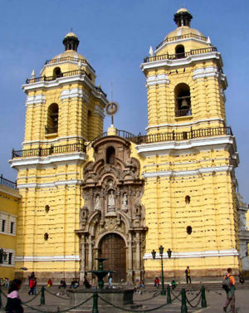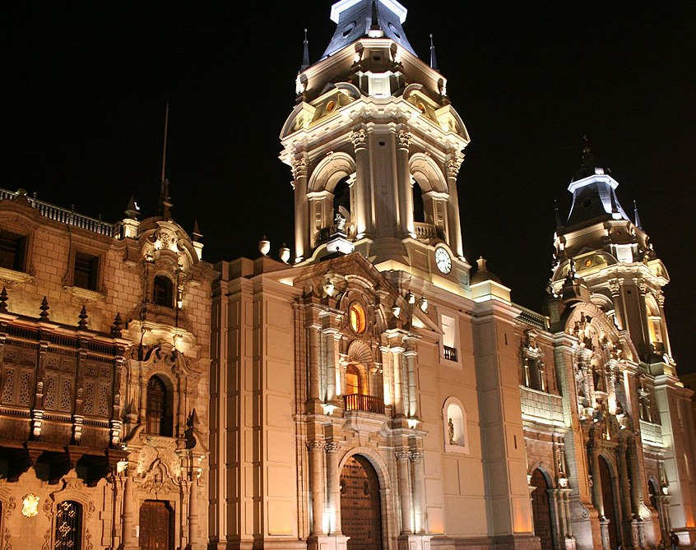

Museo de Oro del Peru (Gold Museum):
Housed in a fortress-like building are the safe-rooms crammed with treasures from the Inca civilisation and their predecessors. The massive collection of gleaming gold, ceremonial objects and jewellery compete for attention, and the famous golden Tumi, the symbol of Peru, has been exhibited around the world. The rest of the museum is just as interesting with thousands of exquisite tapestries, pre-Incan weapons and wooden staffs, masks, mummies, and clothing. There is also a vast display of antique weapons and uniforms, a reminder of Peru's violent past.
Opening time: Daily 11.30am to 7pm

Parque del Amor (Love Park)
Love Park is located on the cliffs of Chorrillos overlooking the Pacific Ocean. It's surrounded by walls of romantic quotes scripted in mosaic tiles and a monumental statue of two lovers embracing each other in the center of the park.
Opening hrs: 6 am-midnight

Miraflores and San Isidro
The districts of Miraflores and San Isidro represent modern Lima with its financial center, upscale hotels and restaurants. Barranco, to the south of Miraflores, is a bohemian neighborhood and has earned recognition for its population of writers and intellectuals.

Excursions from Lima:
Pisco is a small port and fishing village, best known for its fiery white grape brandy of the same name. It also boasts the origins of one of the major ancient civilisations in Peru, the Paracas culture, who left an astounding collection of antiquities that are displayed in the museums of Lima. The area is primarily visited as a base to see the wildlife of the nearby Paracas National Reserve, home to an incredible variety and huge concentration of marine animals and birds. Locals proudly proclaim it to be the ‘Peruvian Galapagos’, and the main focus of a visit to the reserve is a boat tour of the Ballestas Islands. The islands are off limits to people but the boat tours afford spectacular close up views of the wildlife. The rocks are alive with thousands of migratory and resident sea birds, including pelicans, flamingos, penguins, cormorants, red boobies and terns. Huge colonies of barking sea lions line the shores, and turtles, dolphins and sometimes whales are seen in the surrounding waters. En route to the islands boats pass the famous Candelabra, a gigantic trident-shaped drawing etched into the sandstone cliffs overlooking the bay, and like the drawings at Nazca, its origins remain a mystery.
Address: Pisco is 150 miles (95km) south of Lima; Transport: Many buses serve Pisco from Lima. A good option is Ormeno

Nazca
Nazca is a small desert town, named for the Nazca civilisation that came after the Paracas culture, and it is a major attraction due to the mysterious presence of the lines and diagrams etched into the surrounding desert floor. It also has some interesting museums and archaeological sites, including the Chauchilla Cemetery, with 12 exposed underground tombs containing skeletons and preserved mummified forms. The main attraction of the town is an aerial flight over the Nazca Lines that are spread over miles of the vast desert floor. The dimensions of these enormous figures, geometric designs, spirals and perfectly straight lines are so large that the only way to view them is from the air and pilots will point out the outlines of intriguing bird and animal representations such as the hummingbird, monkey, condor, spider, and the unusual cartoon-like character known as the Astronaut. These figures were made by removing sun-darkened stones from the desert floor to expose the lighter coloured stones below, and were created over a thousand years ago. Theories abound regarding the mysterious desert etchings, and questions as to why they were created, how they were designed and what technology was used, remain unanswered and have puzzled experts for centuries. The Nazca Lines are among the most unforgettable and strangest sights in the country, an extraordinary legacy left by the ancient people of the Nazca culture, and one of the great mysteries of South America.

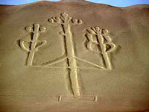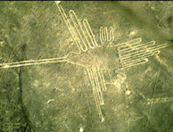

The best way to see the lines is to take to the sky. Flights over the lines leave regularly throughout the day on small planes which take between 3 and 5 passengers. The flight last from 30-40 minutes.
Address: Nazca is a few miles in from the coast, 280 miles (175km) southeast of Lima; Transport: Ormeño and Civa are the best bus companies with offices in Nazca

CUSCO

Flying time between Lima – Cusco 1 hour
Cusco is South America's archaeological capital and oldest continuously inhabited city.

Must Sees
Imperial City, living example of the mixture of the Andean and Spanish cultures. Start the trip visiting the Santo Domingo Convent, built over the Koricancha, and ancient Inca palace and main worship center of the Sun God. Later, we will stop at the Main Square, where you can find the Cathedral and the beautiful Church of La Compañía. Going on with the tour, we will visit the Sacsayhuaman Fortress, imposing sample of military Inca architecture which domains the city. Finally, we will take a look at the archaeological sites of Qenko, Puca-Pucara and Tambomachay, located north east of the city. As a suggestion to mysticism and esoterism lovers, the Sacsayhuaman Complex is an excellent spot to hold meditation sessions.

MACHU PICCHU –ONE OF THE 7 WONDERS OF THE WORLD:

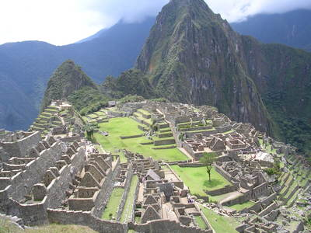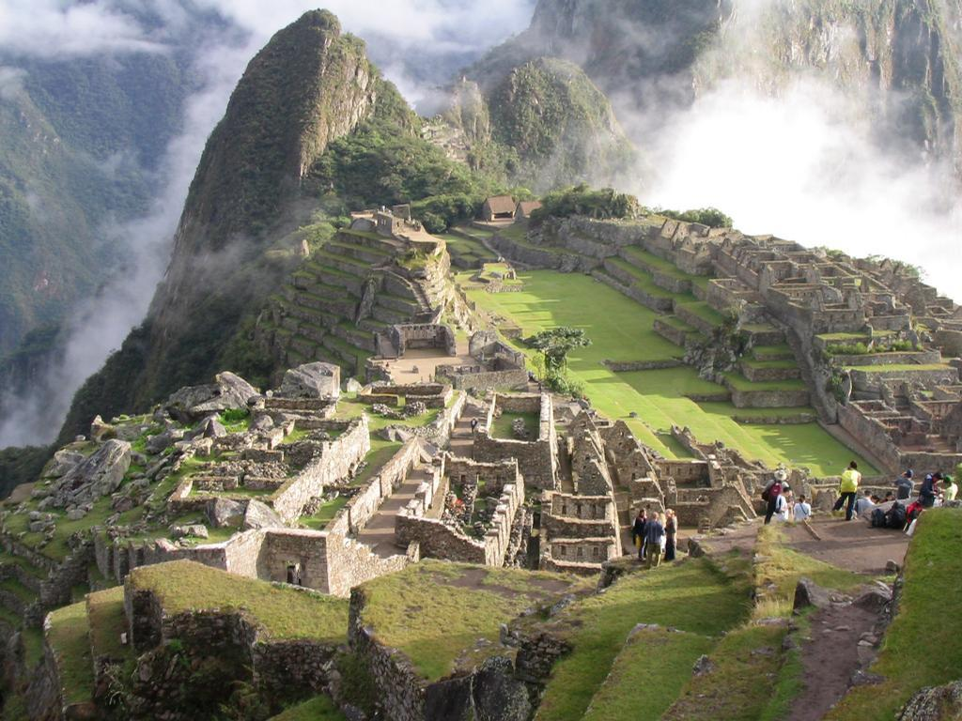

It is located 120 kilometer in the northwest area from Cusco over Urubamba River (it’s a name taken from Vilcanota River), in Vilcabamba Mountains. Its altitude is over 7810 feet above sea level. Machu Picchu citadel is one of the most important archeological places in the entire world and it is the main destination of Peru. Few works made by the man show so much harmony with the nature as this citadel shows us and the 33 archeological groups that are united through Inca Trail.
The archeological complex is located in the top of a mountain, Machu Picchu (quechua word that means “old mountain or the main mountain”) that gives to the citadel the name and the amazing landscape that all of us have seen. In front of it, the amazing mountain of Wayna Picchu appears (“young mountain”) in which between summits and slopes, some archeological remains are located. Both summits limits on the plentiful Urubamba River, that runs to the eastern, at 400 meter under the citadel. (www.andeantravelweb.com/peru)

The excursion is by the exclusive, luxury train “Hiram Bingham”
The train leaves from Cusco in the morning taking a spectacular journey through a changing landscape while guests enjoy breakfast. After the steep climb out of Cuzco, the train descends into the Sacred Valley, passing lush fields and colorful villages in the foothills of the Andes.

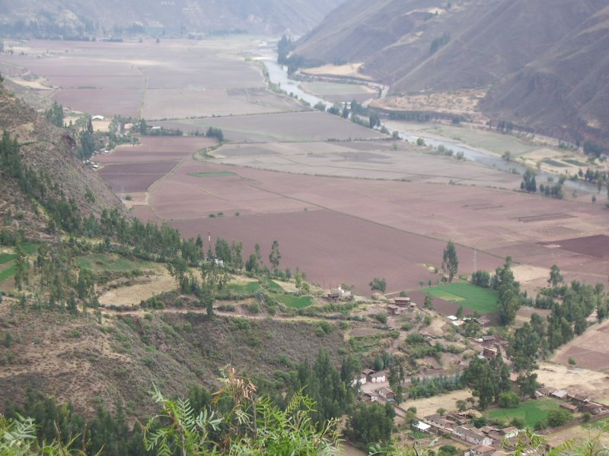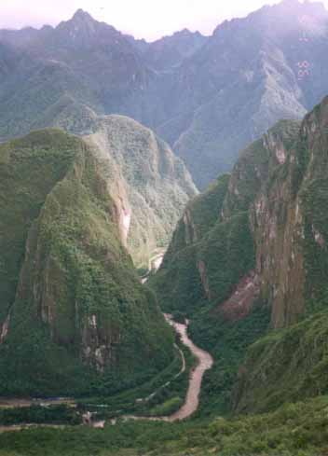

From there, the journey is highlighted by wonderful vistas of the mountains and the beautiful Urubamba River which runs through the Sacred Valley. On arrival in the town of Aguas Calientes at the foot of Machu Picchu, a private guided tour of the citadel follows before the return transfer to the station in the early evening. A sumptuous dinner is served on the train during the 3½ hour journey back to Cusco.
The distinctive blue and gold carriages of the Hiram Bingham are warm and inviting with elegant interior upholstery. The train, consisting of 2 dining cars, a bar car and a kitchen car, can carry up to 84 passengers.
The Hiram Bingham departs Cusco at 9am. Brunch is served on board the train whilst travelers enjoy the spectacular scenery unfolding before them from the large windows. The arrival at Machu Picchu at 12.30pm gives passengers the advantage of entering the Sanctuary at an hour when the majority of the visitors are already beginning to leave for their journey back to Cusco.
Once back on board for a 6.30pm departure, pre-dinner cocktails are served in the bar accompanied by live entertainment before passengers enjoy a 4-course, à la carte dinner, in the dining cars. The train pulls into Poroy station in Cusco at 10pm. (http://www.go2peru.com/hiram_bingham.htm)
THE JOURNEY

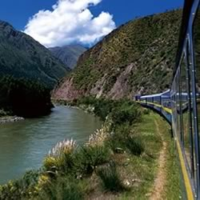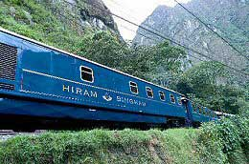
The train leaves from Poroy in the morning, taking a spectacular journey through a changing landscape while guests enjoy breakfast. After departing Poroy and going through Cachimayo, the train descends to the plateau of Anta, a patchwork landscape of typical Andean crops and passes lush fields and colorful villages in the foothills of the Andes.
Far to the left, just below the horizon, the massive agricultural terraces of Jaquijahuana can be seen, close to the village of Zurite. Sadly, these great terraces are all that remain today of what was once a major Inca city, lost forever during the first years after the Spanish conquest.
Beyond the town of Huarocondo the great plain narrows dramatically as the track enters a deep gorge carved by the rushing Pomatales River down which the railway, too, is funneled until it meets the Urubamba River, which runs through the beautiful Sacred Valley.
The train passes through extensive areas of terracing dotted with the ruins of Inca fortresses. Bisecting this are still-visible sections of an ancient, long-abandoned highway adopted by the muleteers of the late 19th century, who used it to travel between Cusco and the rubber plantations of the Amazon lowlands.
5km beyond Pachar, is the village of Ollantaytambo.
As the train leaves Ollantaytambo to begin the last part of its journey to Machu Picchu, the temple complex known as The Fortress.
The railway follows the river into the Urubamba Gorge.
Emerging from a short tunnel, a series of beautiful agricultural terraces marks the ruins of Qente, which in Quechua means hummingbird. In this fertile microclimate fed by a nearby waterfall, giant hummingbirds are indeed a common sight in the early morning and bright flowers bloom all year round.
Surrounded by tall ceibos and rocky outcrops hung with orchids and bromeliads, the train passes Km 104 at Chachabamba, from where the one-day trek to Machu Picchu via the magnificent ruins of Wiñay Wayna begins.
At just 2 km from Machu Picchu, the train arrives at Aguas Calientes. Surrounded by the high, green mountains that cradle the famous lost city, as well as myriad other Inca remains, this small town, which is well known for its thermal baths, has blossomed into a popular overnight destination for travelers to Machu Picchu.
Guests disembark at Aguas Calientes and are taken by bus to Machu Picchu Sanctuary Lodge, overlooking the ancient citadel, for lunch. A private guided tour of the sanctuary follows before the return transfer to the station in the early evening. A sumptuous dinner is served on the 3 ½ hour journey back to Cusco

SACSAYHUAMAN FORTRESS:
Visitors to this magnificent Inca fortress, which overlooks the city of Cusco, cannot fail to be impressed by the beauty and monumental scale of this important Inca construction. Sacsayhuaman can be variously translated as 'speckled falcon' or 'speckled head'.
The duration of the tour is 3.5 hrs. It’s a 30mins drive from cusco city centre and 15mins drive from the hotel.
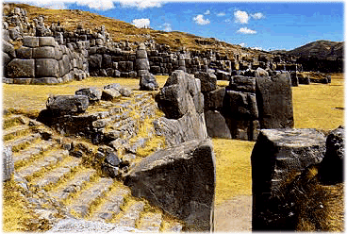
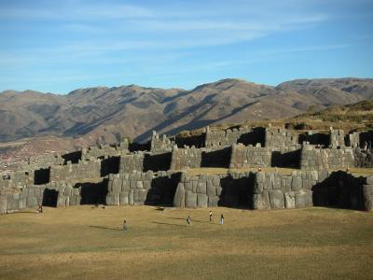

PUCA PUCARA (RED FORT):
Situated on a hill with superb views over the surrounding countryside Puca Pucara was more likely a tambo, or kind of post house than an actual fortress. Travelers may have lodged here with their goods and animals before entering or leaving Cusco. An alternative theory is that it served as a guard post controlling the flow of people and produce between Cusco and the Sacred Valley.
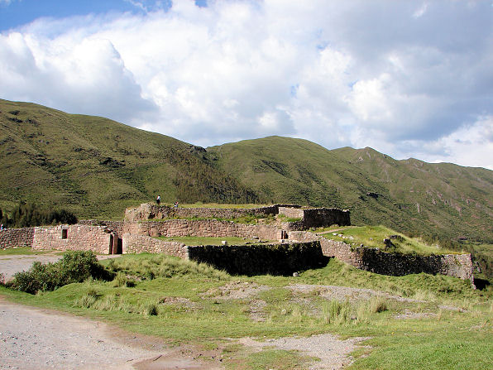

Q'ENKO (ZIGZAG):
This is one of the finest examples of a rock artfully carved insitu showing complex patterns of steps, seats, geometric reliefs and a puma design. The rock is an excellent example of the Inca 'Rock Worship'. In Inca cosmological beliefs the Incas held large rocky outcrops in reverence, as if they possessed some hidden spiritual force. On top of the rock are zigzag channels which served to course chicha (local maize beer) or sacrificed llama blood for purposes of divination; the speed and route of the liquid, in conjunction with the patterns made in the rock, gave the answers to the priest's invocations.
Inside the rock are large niches and a possible altar. This may have been a place where the mummies of lesser royalty were kept along with gold and precious objects.

TAMBOMACHAY (CAVERN LODGE):
Commonly referred to as the 'Baños del Inca' or Inca baths, Tambomachay was a site for ritual bathing. The excellent quality of the stonework suggests that its use was restricted to the higher nobility, who maybe only used the baths on ceremonial occasions. The ruins basically consist of 3 tired platforms. The top one holds four trapezoidal niches that perhaps were used as seats; on the next level an underground spring emerges directly from a hole at the base of the stonework and from here cascades down to the bottom platform, creating a cold shower just high enough for an Inca to stand under. On this platform the spring water splits into two channels, both pouring the last metre down to ground level.

SANTO DOMINGO CHURCH & KORICANCHA / QORICANCHA (INCA TEMPLE OF THE SUN):
Santo Domingo was built in the 17th century on the walls of the Koricancha Temple of the Sun. The finest Inca stonework in existence today is the curved wall beneath the west end of the Church. In Inca times the walls of the Koricancha were lined with 700 solid-gold sheets weighing two kilos a piece. There were life-size gold and silver replicas of corn, golden llamas, figurines and jars.
All that remains today is the stonework; the conquistadors took the rest - unfortunately all the exquisite treasures ended up being melted down; nothing survived. However the fist conquistadors to arrive did not remove the holiest religious symbol of the empire, the golden sun disc, though they reported its existence. This solid gold disc, far larger than a man, mysteriously vanished before the main party of Spaniards arrived. It has never been found to the present day. The disc was positioned to catch the morning sun and throw its rays into the gold-lined temple, filling it with radiant light and bathing the mummies of the dead Inca rulers in sunshine, which were seated in niches along the walls.
The entire temple complex was also an intricate celestial observatory. Every summer solstice, the sun's rays shine directly into a niche - the tabernacle - in which only the Inca was permitted to sit. Along with the main temple dedicated to the Sun, there were others for the adoration of lesser deities - the Moon, Venus, Thunder and Lightning, and the Rainbow.
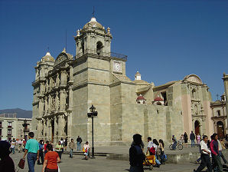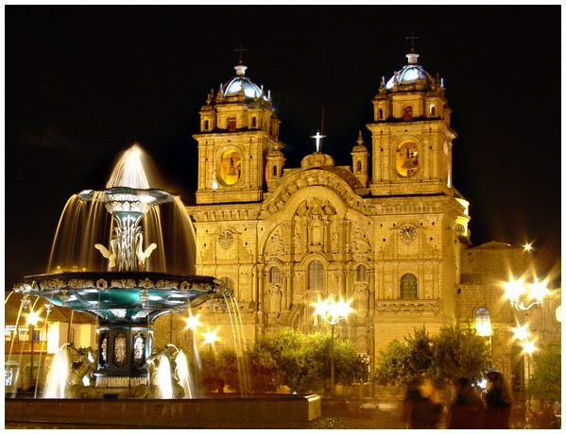

OLLANTAYTAMBO (2,800m):
Ollantaytambo is an attractive little town located at the western end of the Sacred Valley (about two and a half hours by bus from Cusco). The town has been built on top of original Inca foundations and is the best surviving example of Inca town planning. The town is divided in canchas (blocks) which are almost entirely intact. Each cancha has only one entrance (usually a huge stone doorway) which leads into a central courtyard. The houses surround the courtyard.
The town is located at the foot of some spectacular Inca ruins (entrance with the Tourist Ticket 'Boleto Turistico') which protected the strategic entrance to the lower Urubamba Valley.

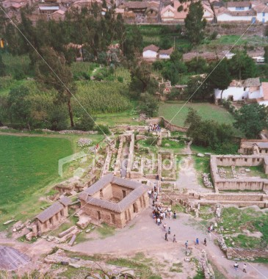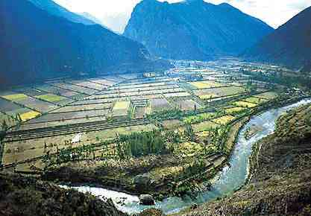

Ollantaytambo became the only place ever to have resisted attacks from the Spanish.
However, the victory was short-lived when the Spanish returned with four times their previous force. Manco Inca retreated to his jungle stronghold in Vilcabamba and Ollantaytambo fell into the hands of the Spanish.
(www.andeantravelweb.com/peru)

PUNO:
The city of Puno is located in the southeast corner of Peru, on the shores of the magnificent Lake Titicaca and is only 126km from the frontier with Bolivia.
At 3,827m in altitude, Puno is a rather cold and bleak town surrounded by the desolate altiplano (or high plateau). It is not so much a destination in itself but a necessary stop on the way to visit the islands on Lake Titicaca, or when crossing the border to Bolivia.
Puno is, however, a melting pot of Indian cultures including the Aymara from the south and the Quechua from the north. This has earned Puno the title of 'Folkloric Capital of Peru' which it lives up to well with its huge number and variety of traditional fiestas, dances and music
Lake Titicaca is the main attraction that draws people to this part of Peru. This amazing deep blue lake, 195 km in length with an average width of 50 km, is the largest lake in South America and the largest in the world above 2,000m.
Lake Titicaca was, according to Andean legend, the birthplace of civilization. The main touristic attraction of Puno is the Titicaca Lake, located in the Collao Plateau. This is the world's highest navigable lake. It has 193 KM long and 64 KM wide, with a maximun depth of 300 meters. Its waters hold a great ichtiological richness. It has a wonderful landscape and the impressive snow capped mountains of the Cordillera Real confere it a mysterious atmosphere. It is said that the Uros, of strong physical condition, who live over the artificial totora islands, are descendants of the oldest race all over the world.
Some great monuments are the Cathedral, the Conde de Lemos's Balcony, the Arch Deustua, the Municipal Paintings Room, the Dryer Museum and the Popular Art Museum. 30 KM away from Puno, capital of the department, are the Chullpas of Sillustani, which were tombs of the hatuncollas' leaders (great men), and many other vestiges of ancient cultures that inhabited the region
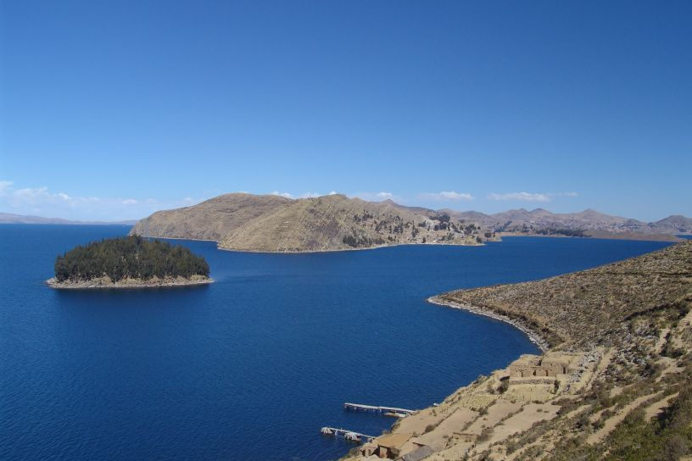

SHOPPING:
For shopping, there are typical markets, for handicrafts, but there are also exclusive jewelries to buy gold and silver goods, of excellent quality. Alpaca wool cloth, sweaters, coats are excellent in Peru, finest wool and excellent quality.
Wall carpets (tejidos), Carvings on stone, wood and dried pumpkins.
Silver and gold jewellery, typical music instruments like pan flutes (zampoñas), skin drums.
Bargaining is very common

Shopping in Lima
Mercado Indio (Indian Market)
Located between 6th and 10th blocks of Avenida La Marina, Pueblo Libre.
This large collection of market stalls sell crafts only, including woollen and alpaca clothing, carved wood objects and jewellery. There's a huge selection and bargaining is expected. The handicrafts markets in Miraflores on Avenida Petit Thouars (blocks 51-54) has a similar, although slightly more expensive, selection

Shopping in Cusco
For Handicrafts
Centro Artesanal Cusco (Market)
Arte Vivo del Cusco al Mundo
Artesania Mendivil (shop and workshop)
Galeria Olave (shop and workshop)
Galeria Latina Cusco
La Perez
Seminario Ceramic Studio (Cusco & Urubamba)
Store of the Weavers of the Southern Andes
Casa Ecologica

For Alpaca Wool
Center for Traditional Textiles of Cusco
Catcco Museum / Store (Ollantaytambo)
Tienda Museo de Josefina Olivera
Awana Kancha (between Cusco and Pisac)
Alpaca III
Alpaca's Best
Alpaca Golden
Werner & Ana
Mon Repos

NIGHTLIFE:
There are various exclusive night clubs, you can also enjoy dinners with folklore shows, in Lima and in Cusco. Nightlife in Lima and Cusco is very active. Also lots of restaurants of different kind of food, opened most of them until midnight.
In Lima, Barranco is a great artsy neighbourhood with cool music. Aside from the discos with the usual rock and alternative stuff, there are also numerous huecos, (holes in the wall) where you can hear wonderful traditional music from Peru’s coast. It is called musica criolla or musica negra.

Lima

Bars and Pubs
La Estacion
Av, Pedro De Osma 112, Barranco
Tel 511 2470344

Dance Clubs
Aura
C.C Larcomar, Miraflores
Tel 511 – 2425516

Gotika
C.C Larcomar, Miraflores
Tel 511 – 2426642

Cusco
Blue Berry Lounge
Portal De Carnes 236
Plaza De Armas
Tel 084 249458

Fallen Angel, Fire and Ice
Plazoleta Nazarenas 221
San Blas
Tel 084 258184

RESTAURANTS:
Lima- Indian restaurants
Curry Treat
Peublo Libre, Lima
Usd5- 6pp

Govinda's
Jirón Callao 480 (at near Av. TACNA in Centro de Lima)
01-4263305
Cash only

Govinda's
Schell 634 Miraflores
014-4442871
Soups, curried stir-frys with rice, and more. Fixed menu costs around 5.5S. Also a small shop selling incense, clothes, health food and snacks. Has an outdoor patio for seating

Restaurants
Poissonnerie Restaurant
Miraflores Park Hotel

La Rosa Nautica Restaurant
10minutes from the Miraflores park Hotel

Bircher-Benner
Av. Larco 413, Miraflores (Lima 18) (at downtown)
Ph 1-4465791
Serves meals, yogurt, fruit desserts, lunch menu Mon-Fri 12-2pm, pizza nights, and more. Also a health food shop. Accept credit cards. Closed Sunday.

El Paraiso de la Salud Restaurante Vegetariano Integral
Jr. Camana 344 (at 1 block from Plaza Mayor/Plaza de Armas, in Centro de Lima)
ph4284591
Small vegetarian restaurant with juice bar. Also sells a few health food products and takeaway food.

El Vegetariano
Cantuarias 285 (at the corner of Ave. La Paz)
Pleasant atmosphere with good service. 7 soles for daily set menu (less than 3.00USD), for big soup, main plate, yogurt, drink and small dessert. Cash only. Open Mon-Sat 9am-8pm, closed Sunday

Astrid y Gaston (International/Peruvian)
Cantuarias 175, Miraflores. Tel 444- 5310, 444-1496.
Run by husband/wife team Astrid and Gaston. Main courses US$15-25
Open Mon-Sat 12:30-15:30 and 19:30-00:00. Reservations recommended

La Hamaca (International/Peruvian)
General Borgono, Block 8 (Huaca Pucllana), Miraflores. Tel 444-4042
Meals cost around US$10-20. Open Mon-Sat 12:30-16:00 and 19:30-23:00. Reservations recommended

Las Brujas de Cachiche (Peruvian/Criollo)
Jr. Bolognesi 460, Miraflores. Tel 444- 5310, 447-1883
One of the best restaurants in Lima for Peruvian food. It is an old mansion converted into bars and dining rooms and is beautifully decorated. Meals cost around US$25-30. Open Mon-Sat 12:30-00:30, Sun 12:00-17:00.

La Rosa Nautica
Espigon 4, Costa Verde, Miraflores. Tel 447- 0057.
This is one of Lima's loveliest restaurants set in a fabulous Victorian-style building at the end of a pier, overlooking the Pacific Ocean. (Sunset recommended). Excellent seafood. Set meals are good value and cost between $20-30. À la carte meals can easily reach over $50.

El Señorio de Sulco (Peruvian/Criollo)
Malecon Cisneros 1470, at the end of Pardo overlooking the sea in Miraflores. Tel 441- 0389.
Excellent criolla food (typical dishes from the coast of Peru). Dishes include fish, meat and vegetarian dishes and cost around US$15-25.

Restaurants in Cusco:
Maikhana Namaskar
Carmen Alto N33
San Blas, Cusco, Peru
Indian restaurant.

Cicciolina
Calle Triunfo 393, 2nd floor, nicely decorated, Spanish / Italian / Mediterranean cuisine, beautifully presented. Nice atmosphere, sophisticated. Separate bar menu includes tapas. A little on the expensive side but overall good value. Recommended, Reservations are a must

Inca Grill (International)
Tel: 262992
Portal de Panes 115, Plaza de Armas.
Inca Grill offers the best food in town and although expensive I think you'll think it's worth it. The menu includes a wide range of typical and international dishes (NovoAndino) including vegetarian dishes. Elegant folk shows are put on each evening. Highly recommended by South American Handbook. Reservations are a good idea. Open Mon-Sat 10am-12am, Sun 12pm-12am

Meson de Espaderos (International)
Tel: 235307
Calle Espaderos 105, 2nd Floor, on the corner of the Plaza. Try the best grilled meats in Cusco while having a great view of the Plaza de Armas. A wide variety of the finest Peruvian wines is available to accompany your meals. Make a reservation or get there early to sit in the attractive balcony overlooking the Plaza.

Fallen Angel
Tel: 258184
Plazoleta Nazarenas 221

Acuarim
Cuesta del Almirante no 211
Cusco Peru

Moni Cafe
San Agustin 311
Cusco Peru
Phone: 00 51 84 231029

Restaurants in Puno
Rico Pan
Moquegua 330, Puno. Tel 35 4179
Cheap pastries, sandwiches and drinks. A pleasant place for breakfast or other meals. Excellent coffees, espresso and cappuccino. It's also a bakery so you can buy loads of delicious cakes to take with you on your boat trip to the islands of Titicaca.

Cafe Internacional
Corner of Libertad and Moquegua, Puno. Tel 35 2502
Probably one of the best restaurants in town but the interior is a little sparse and the service variable. However the food is good and there is plenty of it. Meals cost about $ 4-6 and include pastas, chicken, steak and pizza. You can also have breakfast or just a sandwich.

Pizzeria del Buho
Lima 347, Puno
Well recommended for pizzas and pastas. Warm atmosphere. They often have a daily set menu which is very reasonable although not advertised outside.

Safety Tips
-Emergency numbers in Peru are 011 / 5114, In Lima ring 105.
-In Lima and some of the larger cities there is a sort of local police called "Serenazgo": you may ask for help but they have no tourist oriented services.
- Be aware of your surroundings and try to avoid unlit or unpopulated areas especially at night. There is a lot of petty crime that can turn violent. Avoid groups of male youngsters since there are many small gangs trying to rob passerbys.
-Armed robberies of tourists are common.
A dirty old backpack with valuable contents is safer than a new one with old clothes in it. It's often good not to look too rich.
-Some travelers do not use wallets, but keep the bills and coins directly in their pocket.
-Don't walk around with debit- or credit cards in your pocket. Leave them in a safe place, when you do not directly need them.
- If you want to take large amounts of cash out with you, a neck wallet is always a good idea - you can hide it under your shirt.
-Watch out for false bills. Every bank has posters that explain what to check when getting higher valued bills.
- Ignore any requests to carry luggage or packages for strangers. There could be illegal items or drugs in there.

